TRUCKER DISTRICT

There are **Four** type of user we can create In the Project:

1. Driver
2. Business
3. Recruiter
4. Broker

**Home Page:**

The home or landing page provides the user with the following options:

1. Search Activity (by ZIP)
2. Learn More
3. Log-in
4. **(Detect visitor location, and plot user in background map)**  
   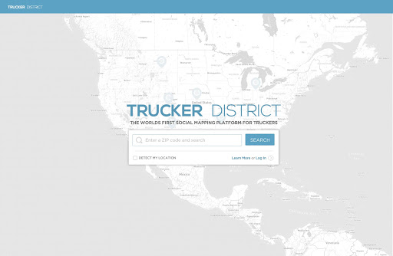

If user perform search, then he/she will be see all available stops (Stored in DB).   
On mouse over/click of particular poin, user can be able to see more detail of stop and can able to visit detail page of stop

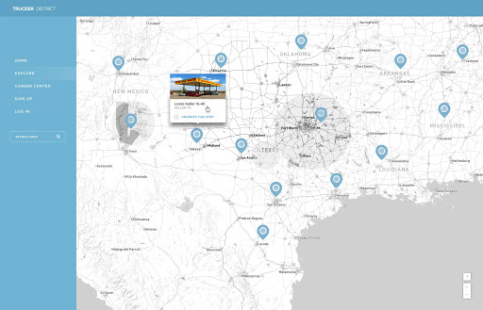

If you click on location/stop tooltip for a truck stop, get the detail for particular stop:

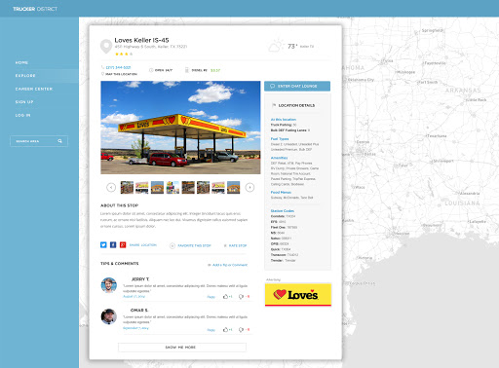

* We will have the zip code query the Map box Api to plot the location and other GEO detail.
* To plot the points on the map and database with latitude and longitude of several thousand stops and additional basic info and will display the detail of particular stop

1. **Signup**
2. **Login with user/pass, social accounts**
3. **Forgot Password**
4. **Dashboard**

After the user logs-in, the lands in the “Dashboard”.   
  
 The Dashboard provides:

- News feed

- Post status (text, image, video embed, etc)

- See Friends and Activities

- On/OFF location setting

- Manage Trips

- Manage Jobs

- Navigate other pages of site.

- Chat with friends

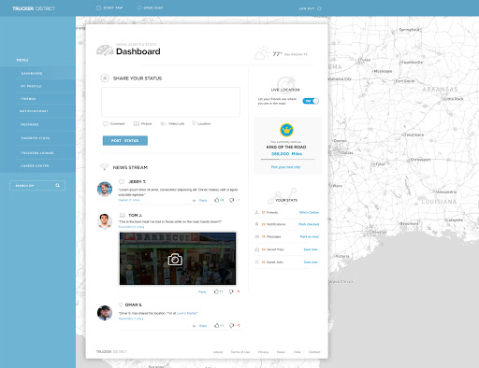

* Now, from here, let’s assume the member goes to his profile page

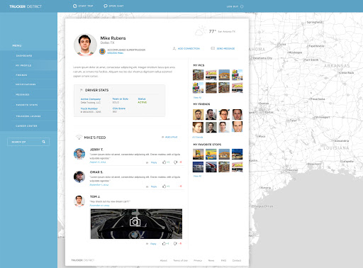

* This is very straight forward driver status on top, next to image basic bio, driver information, and friends posts on his wall.
* on right hand side, photos, friends, and favorite stops widgets
* you can message the user, and connect with him on wall posts, there can be image, text, videos and Right, or a location post
* User can Add/delete/accept/DE client friend request.
* Also user can do direct message to all users or friends only. If you are not someone's friend, you cannot see his page.
* **There will be option to public/private setting for member profile:**
* Only the business pages will be public.
* The member profile pages of driver accounts will be private and only available to their friends.

* **Notifications page: (like FB)** pretty basic

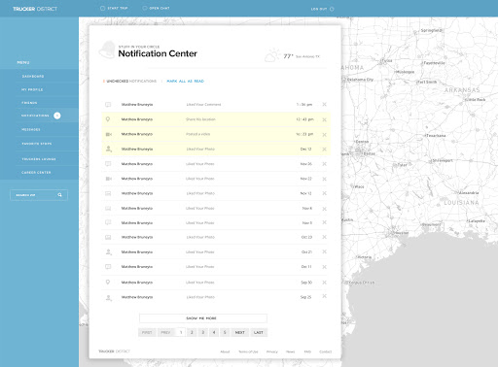

* Self-explanatory page:

This is how the area for direct messages looks

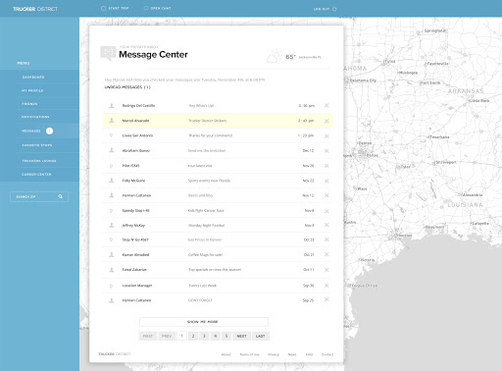

The Favorite stops page:  
  
  
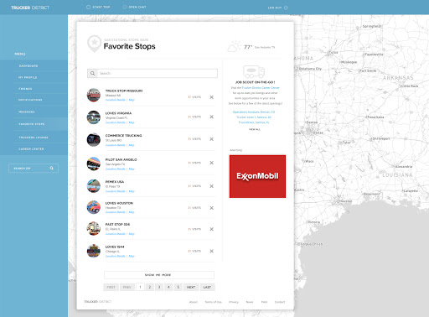

* some templates will adds, so we need to account for a good ad service we can implement, so keep that as a side note  
    
    
    
    
    
    
    
    
  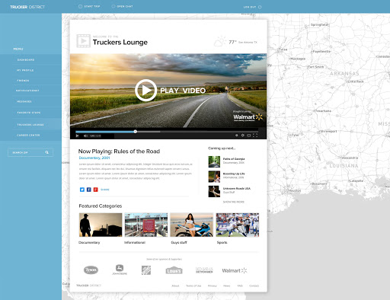
* The Trucker's Lounge will just run YouTube videos, so it will all be embed-based, but we need to have a way to manage the channels on the admin
* So, before I get to the Career Center
* Bottom part of this page Trucker Lounge page
* Those are categories of videos we are going to embed on admin. We need to have different categories, like that. So truckers can go to different topics. So, let me go back to the Dashboard briefly
* So, you see the button that is on the top bar, 'Start Trip'.

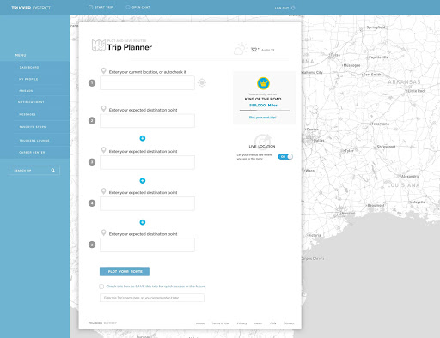

* Trucker will do the plan for his whole trip with date time  
    
    
  the trucker enters initial destination, and then next or final destination. Then we just add the distance/miles traveled from place to place, and add them to the member's mileage. So, intermediate places we will find out and will show on member profile
* If you open a location window you see the detail page:   
    
    
    
  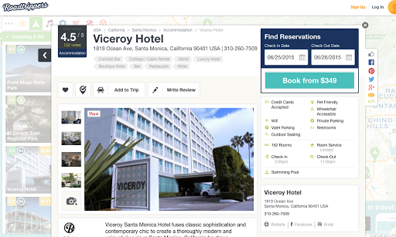
* when user click on location bubble/pin, it opens the detail page over the map  
  and you can close the window, and be back on the map, to see other locations, search for stops on another area, or see friends in the area